**Jobs Recovery Reaches Plateau, Posing a Challenge for Forecasters**

**Companies, Fed policy makers, investors struggle with mixed signals in labor data**

*The Wall Street Journal* - By Eric Morath and Jeffrey Sparshott - Sept. 25, 2016

After a half-decade of steady gains, the U.S. labor market appears to be leveling off. What that plateau means for the economy’s trajectory is one of the biggest questions hanging over policy makers and investors.

Hiring is consistent but slower than in recent years, the unemployment rate is no longer falling and layoffs are holding at a historically low level. But participation in the workforce is stuck near a 40-year low.

If the moderate hiring rate continues, that should keep the unemployment rate in check by absorbing new entrants to the workforce. That’s a good thing, but it might not be enough to deliver significantly higher paychecks for workers or draw discouraged Americans back into the labor force.

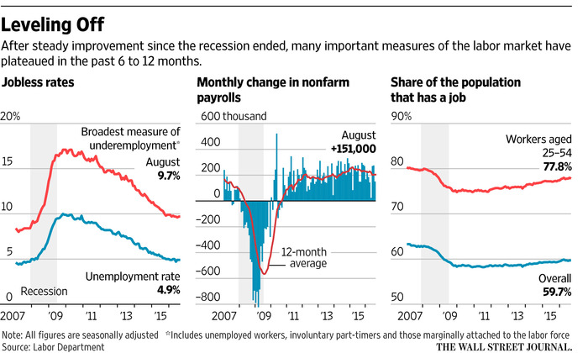

Mixed signals from the labor data pose a challenge to companies forecasting future demand, Federal Reserve policy makers attempting to set interest rates and investors trying to assess the climate ahead.

The labor market “is close to as good as it gets,” given the underlying fundamentals of the economy, said IHS Markit Chief Economist Nariman Behravesh. “But averages hide a lot of problems. A lot of low-skilled and blue-collar workers have been left behind. They might have a job, but it pays less than the job they had before the recession.”

The dichotomy is presented frequently in the presidential race. Democrat [Hillary Clinton](http://topics.wsj.com/person/C/Hillary-Clinton/6344) positions herself as the candidate to maintain President [Barack Obama](http://topics.wsj.com/person/O/Barack-Obama/4328)’s policies that delivered a long, relatively steady expansion. Republican [Donald Trump](http://topics.wsj.com/person/T/Donald-Trump/159) seizes on the frustration of Americans who feel left out of that recovery.

The unemployment rate peaked at 10% in October 2009, just after the recession ended and less than a year after Mr. Obama was elected. U.S. employers have consistently added jobs since late 2010. For the next five years, most measures of the labor market gradually improved, before leveling off in the past six to 12 months.

Some gauges are at historically strong levels. The unemployment rate has been at or just under 5% for nearly a year. The 12-month moving average of job creation, at 204,000 a month, is above the long-run average.

But other measures have stalled out, and remain weaker than before the recession. A broader measure of unemployment that includes discouraged workers and those stuck in part-time jobs was 9.7% last month. It’s been little changed for almost a year. And the share of Americans ages 25-54 with jobs, 77.8% in August, is near a postrecession high, but has changed little since January.

The data has left the Fed frozen this year. Chairwoman [Janet Yellen](http://topics.wsj.com/person/J/Janet-Yellen/5513) last week pointed to modest wage improvement and workforce participation as signs the jobs market is strengthening. Yet central bankers didn’t view the economy as strong enough to withstand the first increase in their benchmark interest rate since December.

The unemployment “rate and other measures of labor utilization are little changed since the beginning of the year,” Ms. Yellen said. “I don’t see that as bad news because it may reflect that the strong labor market is attracting people from outside the labor force back into employment.”

Ms. Yellen and other Fed officials have said they expected hiring to slow and the unemployment rate to level off as slack in the labor market diminishes. But in previous expansions, long stretches of sideways movement in labor measures were followed by an economic downturn.

“I do think that it’s fair to say that the pace of improvement has slowed,” said Tom Porcelli, chief U.S. economist at RBC Capital Markets. “The plateau can go on for a while, or a slow easing toward a recession can go on for a while.”

That can leave businesses uncertain, especially when the lackluster expansion in the U.S. is outpacing developed economies in Europe and Asia. Companies have already reacted by curtailing capital investment, creating a drag on the U.S. expansion this year, which has so far been offset by consumer spending.

“The economy has been growing very slowly for a number of years now, and we don’t expect it to materially change for quite a long time,” [Texas Instruments](http://quotes.wsj.com/TXN) Inc.Chief Financial Officer Kevin March told investors this month.

The U.S. economy has been mired in 2% annual growth for seven years, the weakest expansion since World War II. When the labor market took off in 2014 and 2015 to produce the best jobs gains since 1999, many economists predicted robust gains in gross domestic product would follow. They haven’t. Growth in the first half of this year slowed to a 1% pace.

Some economists now worry that a leveling-off of the labor market might mean hiring is sinking to match weak growth.

“Gradually I think things will slow down,” said Sung Won Sohn, an economist at California State University, Channel Islands. The overall economy is already weighed down by weak business spending and global headwinds. “Sooner or later that will get to employment,” he said.

**Fed Stands Pat, but Says Case for Rate Increase Has Strengthened -- Update**

*The Wall Street Journal* - By Jon Hilsenrath and David Harrison – September 21, 2016

WASHINGTON -- The Federal Reserve left short-term interest rates unchanged Wednesday after a meeting marked by internal divisions, but signaled it still expected to raise them before year-end.

Its stance underscored the lack of urgency the U.S. central bank's leadership feels about lifting rates when inflation is lingering below its 2% goal and the unemployment rate is holding steady at a low level just under 5%.

It also showed the challenge faced by Fed Chairwoman Janet Yellen, who is trying to balance divergent views inside the Fed about how to proceed. One camp of policy makers wants to move rates up right away while another sees no need to raise rates at all this year.

"We judged that the case for an increase had strengthened but decided for the time being to wait for continued progress toward our objectives, " Ms. Yellen said in her press conference following the meeting.

Disagreements over timing drove three regional bank presidents -- Esther George, Loretta Mester and Eric Rosengren -- to dissent because they wanted to move rates up at the September meeting, a rare challenge to Ms. Yellen's leadership.

Forecasts released by the Fed showed 10 of 17 officials expected to raise the central bank's benchmark federal-funds interest rate -- an overnight interbank lending rate -- by a quarter percentage point by December, to a range between 0.5% and 0.75%. Three officials don't see a move at all this year. However, four wanted more than one rate increase, a divergence that reflects the broader divisions inside the central bank about how to proceed.

While it displayed patience about moving rates, the Fed's description of the economy was generally upbeat.

Fed officials have become less worried about risks to the economic outlook, a potential opening to raising rates before year-end. Officials had grown concerned about a range of global problems earlier in the year, including Britain's decision to exit from the European Union and China's uncertain economic outlook. In its postmeeting policy statement, the Fed said risks had become "roughly balanced," meaning the economy has just as good a chance of exceeding the Fed's growth estimates as of falling short.

This risk assessment is often a clue about whether the Fed expects to move rates in the months ahead. When officials see risks that worry them, they aren't inclined to move rates up.

Ms. Yellen noted that the unemployment rate has held steady at or near 4.9% since the beginning of the year even though employers have added about 180,000 jobs a month this year. That means potential workers are coming off the sidelines, suggesting there remains some slack in the labor market.

Policy makers judged it made sense to postpone the next rate increase to absorb some of the remaining slack, Ms. Yellen said.

"We found the economy has a bit more running room," she said. "Nevertheless, we don't want the economy to overheat, and if things continue on the current course, I think some gradual increase will be appropriate."

The Fed's next policy meeting, Nov. 1-2, is a week before the U.S. presidential election, and action is unlikely then, leaving a mid-December policy meeting as the Fed's last scheduled chance this year to push rates higher.

The Fed's broader message Wednesday was that it was doubling down on its promise to lift borrowing costs very gradually.

The median of officials' projections showed they expected to raise the benchmark rate, likely in quarter-percentage-point steps, two more times in 2017, to between 1% and 1.25%, then three times in 2018 to between 1.75% and 2%, and three times in 2019 to between 2.5% and 2.75%.

That marks a shallower path of rate rises than the Fed projected in June, when they forecast two increases in 2016, three in 2017 and three more in 2018. A year ago, the Fed expected to move rates up four times in 2016, but has held the fed-funds rate steady since December in a range between 0.25% and 0.5%.

The policy statement borrowed from a speech given by Ms. Yellen at the Kansas City Fed's conference in Jackson Hole, Wyo., in August, when she said the case for a rate increase had strengthened. But she also stressed at the time the uncertainty surrounding the Fed's forecast, a nod to arguments that the U.S. is vulnerable to unexpected turbulence abroad.

U.S. economic growth was disappointing in the first half of the year. Output expanded at an annual rate of just 0.8% in the first quarter and 1.1% in the second.

The Fed said the economy picked up from a modest pace more recently. However, recent data have been mixed. Industrial production and retail sales declined in August, reflecting weak demand for manufactured goods and skittishness among consumers.

Almost 74% of economists surveyed by The Wall Street Journal earlier this month said the Fed's next interest-rate increase would come in December.

Several Fed officials have lowered expectations for how high they might raise rates over time because of fundamental changes in the global economy.

Aging populations, slower productivity growth and the rise of wealthier emerging markets looking to invest their savings have triggered broad shifts. As a result, officials believe the natural interest rate -- the inflation-adjusted interest rate at which inflation and employment stabilize -- will remain lower than it has been in the past. Economic growth and inflation likewise would grow more slowly.

That means the Fed has less work to do raising rates over the next few years. It also gives officials less room to cut them in a financial crisis or another economic downturn.

**Key hurdles for the U.S. economy could soon disappear**

MarketWatch.com - By Joseph Adinolfi - September 14, 2016

Two major impediments to economic growth in the U.S. are fading fast, according to Torsten Slok, chief international economist at Deutsche Bank, in a note published Wednesday.

U.S. exports should see a continued boost now that the dollar’s sharp appreciation is fading. And stable oil prices should help boost energy firms’ profits in the coming quarter, lifting overall earnings for the S&P 500.

All of this translates into good news for stocks. Shares tend to rise when earnings improve, and when economic fundamentals, like gross-domestic-product growth, are strong.

This seems to contradict the air of uneasiness permeating this market, as stocks remain near record highs reached in August even as the Federal Reserve appears ready to raise interest rates again. Many market strategists and fund managers, [including NorthmanTrader’s Sven Henrich,](http://www.marketwatch.com/story/investors-have-only-a-few-months-to-get-ready-for-the-next-stock-meltdown-2016-09-13) feel a correction for stocks is imminent.

Indeed, shares edged higher on Wednesday following a sharp selloff a day ago. The S&P 500 index [SPX, -0.57%](http://www.marketwatch.com/investing/index/spx?mod=MW_story_quote) was up 0.2% at 2,125 in recent trade. Meanwhile, the U.S. dollar is moving lower, with the ICE U.S. Dollar index [DXY, -0.08%](http://www.marketwatch.com/investing/index/dxy?mod=MW_story_quote)  sliding 0.4% to 95.2920.

“The negative effects on the economy from lower oil and higher dollar continue to fade, and we should over the coming quarters see a boost to exports and corporate profits and ultimately GDP, see charts below,” Slok said in the note.

Slok illustrates his findings in the charts below:

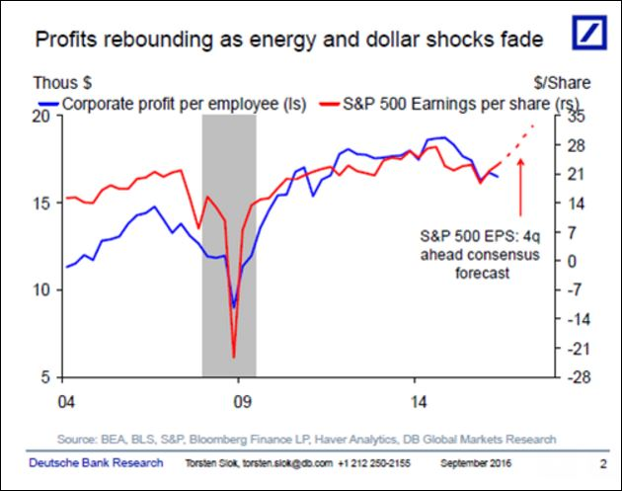

The dollar’s recent weakness should help boost U.S. exports, which in turn should help drive economic growth.

Slok expects earnings per share to surpass consensus forecasts in the fourth quarter.

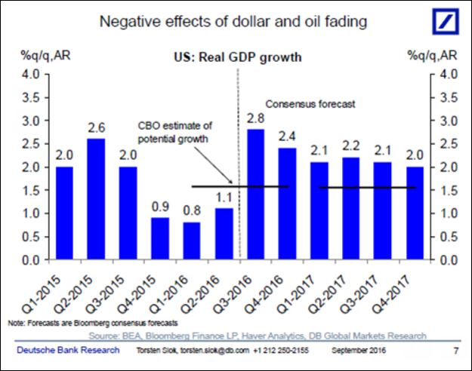

Deutsche Bank expects quarterly growth to improve over the coming year.

Slok is known for his optimistic view on the U.S. economy. In another note published Monday, Slok pointed to the continued growth in bank lending as a sign that the U.S. economy will continue to expand.

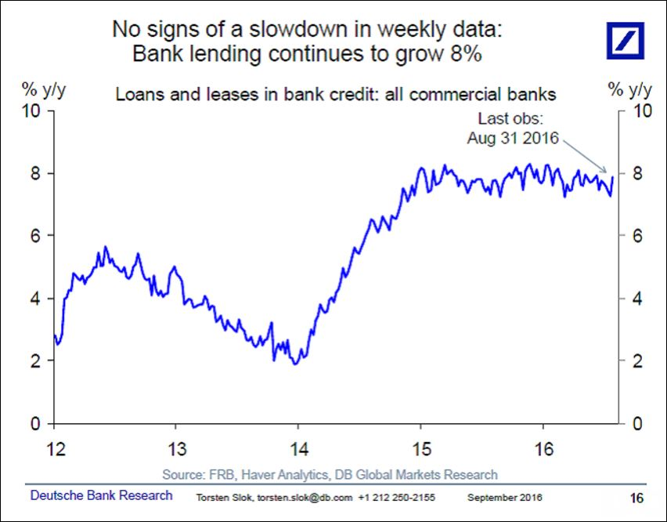

Bank lending in the U.S. continues to grow, which suggests business investment is growing as well.

Investors are nervous after the U.S. economy disappointed economists’ growth expectations in the second quarter. The pace of growth [was just 1.1% last quarter.](http://www.marketwatch.com/story/second-quarter-gdp-still-weak-11-2016-08-26) Economists had widely expected twice that rate.

**Homebuilder sentiment jumps to 65 in September, highest level in nearly a year**

CNBC.com - [Diana Olick](http://www.cnbc.com/diana-olick/) – September 19, 2016

|  |  |  |  |  |  |  |  |  |  |  |  |  |  |  |  |  |  |  |  |  |
| --- | --- | --- | --- | --- | --- | --- | --- | --- | --- | --- | --- | --- | --- | --- | --- | --- | --- | --- | --- | --- |
|  | |  |  |  | | --- | --- | --- | |  |  |  | | |  |  |  | | --- | --- | --- | |  |  |  | | |  |  |  | | --- | --- | --- | |  |  |  | | |  |  |  | | --- | --- | --- | |  |  |  | | |  |  |  | | --- | --- | --- | |  |  |  | |

Americans are making more money, and that is making the nation's homebuilders feel a lot better about their business.

A monthly survey of builder confidence jumped a striking six points in September to the highest level in nearly a year. The National Association of Home Builders/Wells Fargo Housing Market Index (HMI) hit 65; anything above 50 is considered positive sentiment. August's reading was revised down one point. The index stood at 61 one year ago.

"As household incomes rise, builders in many markets across the nation are reporting they are seeing more serious buyers, a positive sign that the housing market continues to move forward," said NAHB Chairman Ed Brady, a homebuilder and developer from Bloomington, Ilinois. "The single-family market continues to make gradual gains and we expect this upward momentum will build throughout the remainder of the year and into 2017."

A worker attaches roofing to a house under construction at the KB Home Magnolia at Patterson Ranch community in Fremont, California, June 20, 2016.

Of the index's three components, current sales rose six points to 71, sales expectations in the next six months rose five points also to 71. Buyer traffic jumped four points but still stands just below positive territory at 48.

Home sales are usually strongest in the spring and fall, but Bob Youngentob, president and co-founder of EYA, a developer in the Washington, D.C. metropolitan area, said he was surprised at the uptick this summer.

"We are definitely feeling better. The summer was excellent. Sales and traffic picked up strongly. It seems like there is a lot of enthusiasm in the buyers," said Youngentob. "Interest rates have been low for a long time, and there is concern they may rise. Buyers on the fence are finally motivated to make a move."

He is not, however, able to raise prices much, and for most builders that has been the case. With costs rising for materials, that puts pressure on margins.

"I just don't think there has been enough consistent demand to get too aggressive with prices. We have been relatively conservative in price increasing," he added.

While builders are clearly feeling much better about their buyers, some are not as happy about their ability to meet the growing demand.

"With the inventory of new and existing homes remaining tight, builders are confident that if they can build more homes they can sell them," said NAHB chief economist Robert Dietz. "Though solid job creation and low interest rates are also fueling demand, builders continue to be hampered by supply-side constraints that include shortages of labor and lots."

Regionally, on a three-month moving average, the Northeast and South each registered a one-point gain to 42 and 64, respectively. Confidence among builders in the West rose four points to 73. The Midwest was unchanged at 55.